Customer Shopping Behavior Analysis

- Project Overview
This project analyzes customer shopping behavior using transactional data from 3,900 purchases across multiple product categories. The primary objective is to uncover meaningful insights into customer spending patterns, segmentation, product preferences, and subscription behavior to support strategic business decisions.

By examining demographic factors, purchase details, and behavioral indicators, this analysis helps identify trends that can improve marketing strategies, customer targeting, and revenue optimization.

- Data Summary
Total Rows: 3,900
Total Columns: 18

Key Features Include
- Customer Demographics: Age, Gender, Location, Subscription Status

- Purchase Details: Item Purchased, Category, Purchase Amount, Season, Size, Color

- Shopping Behavior & Engagement: Discount Applied, Promo Code Used, Previous Purchases, Frequency of Purchases, Review Rating, Shipping Type

- Missing Data: 37 missing values identified in the Review Rating column

- Exploratory Data Analysis (EDA) Using Python
- Data Loading : The dataset was imported using the pandas library.
- Initial Exploration:
* df.info() was used to examine data types and missing values
* df.describe() was used to generate summary statistics
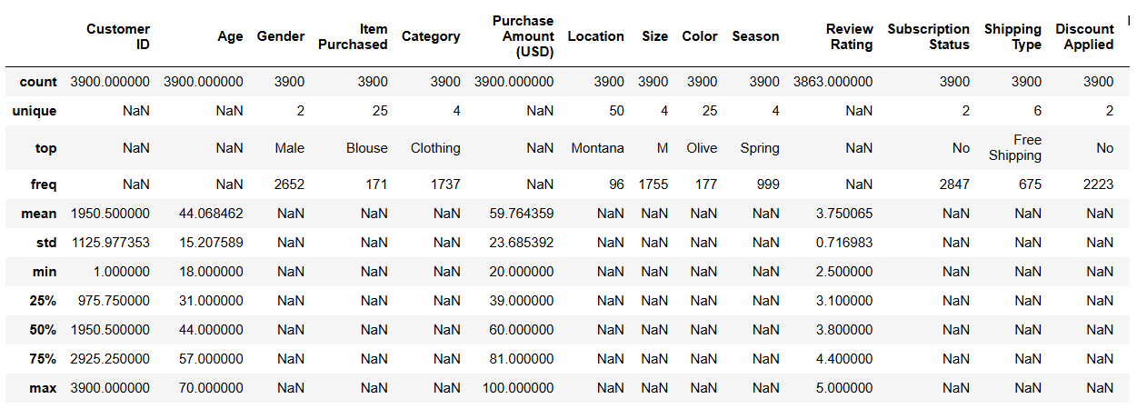

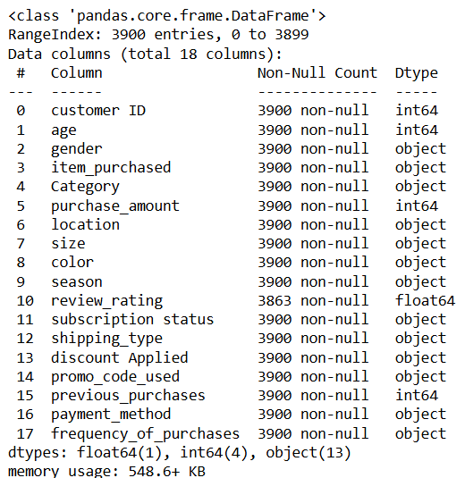
• Missing Data Handling:
Checked for null values and imputed missing values in the Review Rating column using the median rating of each product category.
• Column Standardization:
Renamed columns to snake case for better readability and documentation.
• Feature Engineering:
○ Created an age group column by binning customer ages.
○ Created a purchase frequency days column from purchase data.
• Data Consistency Check:
Verified whether discount applied and promo code used were redundant; dropped promo code used.
• Database Integration:
Connected the Python script to PostgreSQL and loaded the cleaned Data frame into the database for SQL analysis.

- Data Analysis Using MySQL

We performed structure analysis in MySQL to answer key business question:

- Revenue by Gender – Compared Total revenue generated my Male vs Female customer.
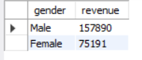
- High-Spending Discount Users – Identify customer who used discount but still spent above the average purchase amount.

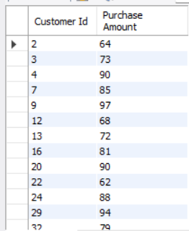

- Top 5 Product by Rating – Founder product with the highest average review rating.

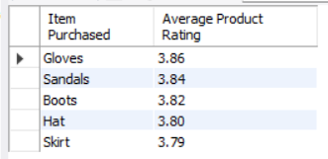

- Shipping Type Comparison – Compare average purchase amount between Standard and Express shipping.

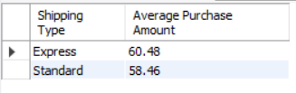

- Subscribers vs Non-Subscribers – Compared average spend and total revenue across subscription status.

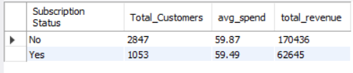

- Discount-Dependent Products – Identified 5 products with the highest percentage of discounted purchases.

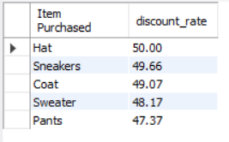

- Customer Segmentation – Classified customer into New, Returning, and Loyal segments based on purchase history.

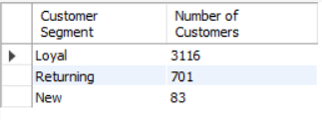

- Top 3 Products per Category – Listed the most purchase within each category.

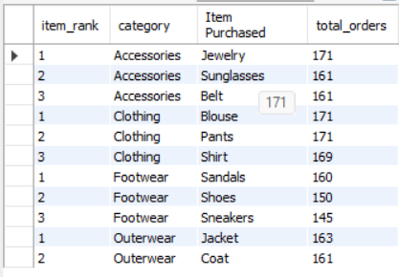

- Repeat Buyers & Subscription – Checked whether customer
customers with>5 purchase are more likely to subscribe.

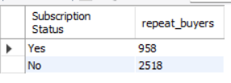

- Dashboard in Power BI

Finally, we built an interactive dashboard in Power BI to present insights visually.
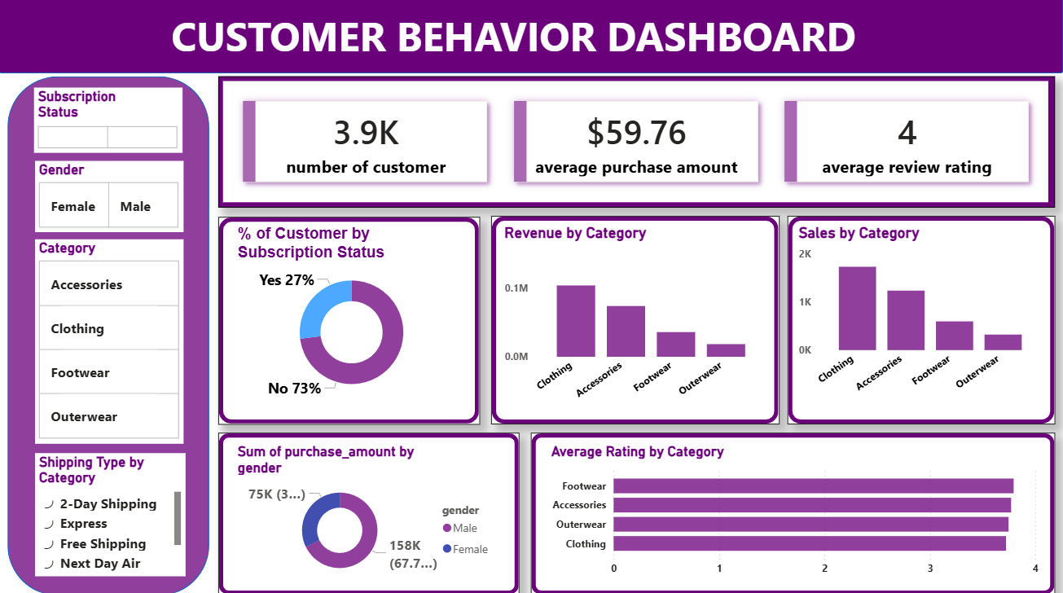

- Business Recommendations

1. Target the Right Age Group
Focus marketing on the age group that buys the most.

2. Reward Frequent Customers
Give special offers or loyalty benefits to customers who purchase often.

3. Promote High-Rated Products
Show and stock more products that have good review ratings.

4. Simplify Discounts
Use simple discounts instead of complicated promo codes.

